Greater Sunshine Coast Provenance Framework

DRAFT Discussion Paper Members Only Review
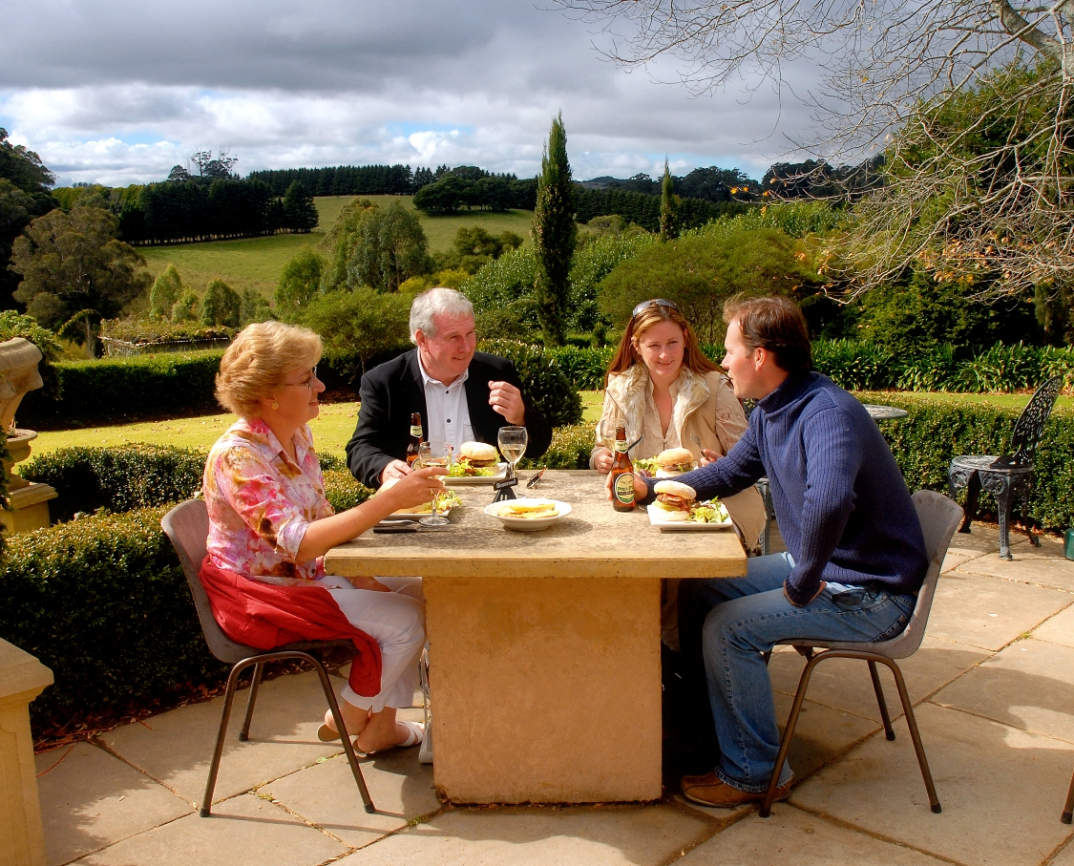
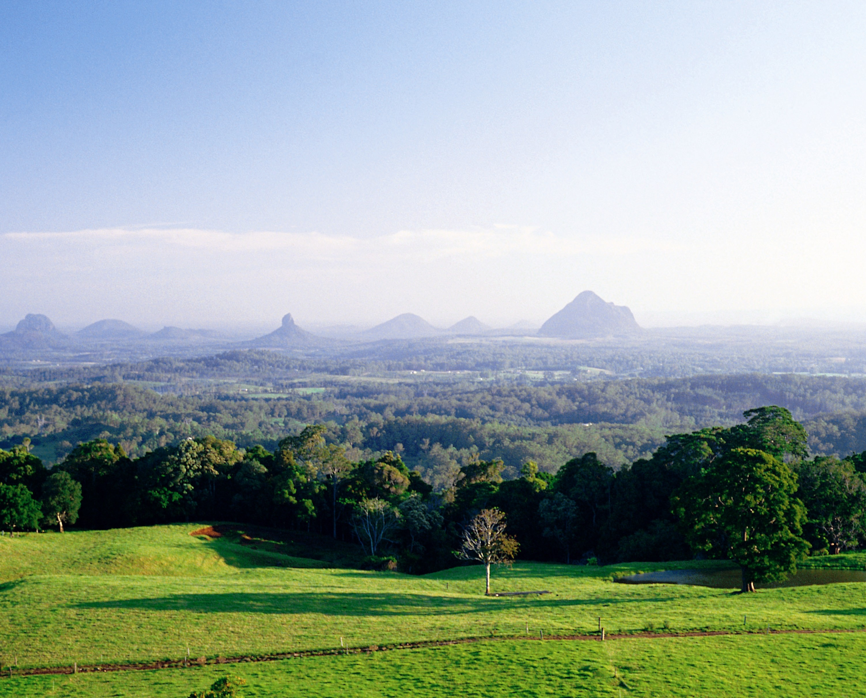
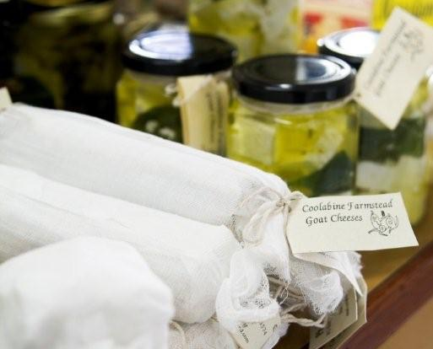
Prepared for: Food and Agribusiness Network, Greater Sunshine Coast Region
Prepared by: Rose Wright, Managing Director

Greater Sunshine Coast Provenance Framework 1
DRAFT Discussion Paper Members Review 1
PART 1. BACKGROUND AND CONTEXT 3
Why create a provenance framework? 3
Provenance – The story behind our food and drink 3
industry consultation 5
Summary of ideas 5
Regional Footprint 5
What does provenance look like in the Greater Sunshine Coast context? 6
What are the values that underpin the concept of Provenance? 7
How will provenance be applied? 9
Crafting our Provenance Story 10
Part 2 The Provenance Framework 11
Why Provenance? What is our purpose? 11
The Purpose 11
Provenance Values 12
Provenance Story 13

PART 1. BACKGROUND AND CONTEXT

Why create a provenance framework?

Provenance – The story behind our food and drink

The 21st century is bringing profound changes to the way we communicate, do business, shop and even plan our next meal. Digital communication provides a platform for each of us to connect and communicate across the globe. More and more people are choosing to buy products online from virtual stores; this phenomenal growth in ecommerce means that many consumers are abandoning going to the shops to buy everyday items and retreating to their device of choice to shop and have it home delivered. This consumer behaviour is causing some to predict that there will be fundamental changes to the way our towns, villages and shopping malls will operate in the future.

Yet, by complete contrast consumers are bucking this trend when it comes to the food they eat. At a time when global growth of online retail is burgeoning, more and more people are keen to discover the provenance of the food they share with family and friends. Who produced it, where it was grown, caught or raised and how it travelled from its place of origin to their plate. In short they are keen to understand the provenance of their food and are using this information to inform their shopping and dining choices.

Provenance is a term rarely used as little as two years ago. Indeed I would have to take the time to explain the concept before starting a conversation about food and food systems. In a very short period of time the use of the word provenance has slipped into our everyday language.

So what is provenance and why do we care about it?

From a consumer perspective, provenance is about understanding the origins of an item and importantly this is not just about location. For a product to have provenance, you will need to understand its history, the story of where and how it came to be, and the journey it has taken to reach you.

When it comes to food and drink, provenance has a particularly important role to play. At a time when global consumption means that ingredients are shipped as commodities from one part of the world to another for processing and packaging, before they are shipped to your local supermarket or shop, it is important to understand the journey of what you consume and feed your family.

We are very fortunate that in Australia we have arguably the strictest food and farming regulations in the world, all with the aim of making our food and drink the cleanest and safest available. In global terms it means our food is highly sought after in other countries. People with less secure and safe food systems seek out Australian produce and value added goods because of our strong reputation.

From a local or domestic perspective, perhaps we as consumers have been a little complacent, not realising just how lucky we are to have such amazing food available to us in abundance everyday. But as more and more of Australia’s best produce is exported, so too we are seeing an increase in the volume and number of food products being imported from other countries, with systems that do not offer the same level of food safety and integrity as our own.

New labelling laws will soon start to improve information about where ingredients are sourced, but this will only go so far. Consumers are seeking a greater level of information about the provenance of food and the ingredients. With recent cases such as the imported berry scare here in Australia and the melamine in foreign baby milk products, along with the increased focus on personal health and wellbeing, it’s easy to understand why consumers care about provenance!

Our food and agribusiness industry, from large manufacturers to small family farms, go to extraordinary lengths to provide absolute transparency about their products. Ultimately though, it is up to the consumer to ask the question and demand an accurate answer of the provenance of the foods they are buying. It is our own responsibility to understand seasonality and what grows in our regions.

At a time when the average Australian farm receives around 10% of the price the consumer pays in the shops for fresh food, we as consumers need to absolutely care about food provenance. If we don’t we are in real danger of losing our Australian producers and in turn access to high quality and safe Australian food.

industry consultation

Around 50 FAN members and industry stakeholders participated in a workshop held on 30 August 2016 at Flame Hill Vineyard in Montville, to explore developing a provenance framework for the Greater Sunshine Coast Region’s food and agribusiness industry. Those who attended demonstrated overwhelming support for the concept and expressed the importance of ensuring it reflects the values of FAN’s membership base and tells the unique story of food from the Greater Sunshine Coast Region. Below is a snapshot of the themes that emerged from the discussion, which underpin the draft Provenance Framework developed.

Summary of ideas

Regional Footprint
The workshop determined that the Greater Sunshine Coast Region encompasses the four local government areas known as The Sunshine Coast Region, Noosa Region, Gympie Region and Moreton Region. It also concluded that there may be scope to include businesses on the borders of these regions if they adhere to the values and conditions set out in the Provenance Framework.

What does provenance look like in the Greater Sunshine Coast context?
The provenance of food can be as complex as the recipe or menu on offer. Region’s need to consider how they want their Provenance Framework to work for them, its purpose and management. The reality is that it may be interpreted in different ways in different regions. We asked the group what they thought it might look like in their context. The following is a summary of their key statements.

The value set that underpins provenance needs to reflect the region’s identity | It needs to tap into different consumers and target markets so our story can be different | Integrity – Trust | We need to have a consistent message that is based upon collaboration, distribution and innovation
“Quality, unique, consistency, flavour, value, story, innovation | Innovation & creativity. Identifiable. Perception - message | Culture & education. Lower carbon footprint | Celebrate our diversity, organics, seafood, fresh food, dairy, value added
Integrity – green, safe | “It’s about our food tourism experience, sea, place. Paddock, plate” | A reflection of the region’s visual beauty, our diversity, ocean and paddock across the whole menu = Our USP | It’s about being sustainable, ethical & transparent
Technology | Lifestyle choice – Quality of life | Niche Producers | Diversity
Natural uniqueness of the environment | Innovation and creativity

It was agreed that provenance is not black and white; there needs to be scope for different types of producers and value adders and indeed the tourism and hospitality industries. Here’s a summary of how they described it
“It’s about sharing information, knowledge capture & transfer.”
“We need to leverage the value of provenance - If it's not remarkable, it's invisible.”
“There are shades of grey. It’s not black and white and it will depend on who the target market is and who’s telling the story.”

Tell (educate) everyone else – locals & visitors  • Tell a story of sustainability  • Retain & transfer knowledge  • Because it sets us apart  Cause  • Improve agribusiness  • Growth  • Reducing food waste  • Value = $ = results  • Motivate (educate) other businesses to be here  Belief  • Informed decisions  • Integrity  • Tasty, whole food, clean & green  Superior ingredients | Generate Value (to Greater SC, consumer–whole chain)  • Trust (connection through collaboration)  • Image/story  • Credibility – identity  • Transparency  • How do they know it’s local?  • Supply chain | Why – building trust  Diversity of offerings (able to offer the whole menu)  Point of difference (USP) –  - Remarkable – innovation  - How to cover various regions – how to tie it all together  Pride – Got to own it! Tell everyone (consumers, government, food tourism)  Integrity – trust/authenticity  To help local community – create jobs  Purpose – security for growers, producers, consumers Reputation leading to increased sales & support for economy
Build demand by developing regional awareness and appetite.  To generate sustainable business | People want clean food. Where does my food come from? More Knowledge  Tell our story  More accessible/available  Create awareness | Lifestyle/experience  Choice  Diversity  Beauty/landscape  Personal story & connection

What are the values that underpin the concept of Provenance?
We asked the groups to discuss the values they wanted reflected in their provenance system. Two themes of “Integrity, Authenticity and Trust” along with “Sustainability” were common across all groups. “Collaboration” was very strong with “Innovation” and “Quality or Best Practice” being supported by half the groups. Whilst commercial viability was raised, it did not gain as much support as a value for provenance and is seen as something that underpins the success of the system.

Attribute | Group 1 | Group 2 | Group 3 | Group 4 | Group 5 | Group 6
Integrity/Trust/Authenticity | ❑ | ❑ | ❑ | ❑ | ❑ | ❑
Sustainability/Respect the environment - custodians, clean | ❑ | ❑ | ❑ | ❑ | ❑ | ❑
Community/collaboration |  | ❑ | ❑ | ❑ | ❑ | ❑
Innovation/knowledge |  |  |  | ❑ | ❑ | ❑
Quality/Best Practice | ❑ |  | ❑ | ❑
Commercial viability | ❑ | ❑

How will provenance be applied?
We explored options of how to apply provenance in the Greater Sunshine Coast context. The discussion explored a range of ways to use and manage provenance. There was support for the development of a provenance mark to help producers and value adders stand out, however there were many questions as to how this might work. We also asked them to consider if there was a need to create a framework of different levels of provenance, again strong support for this concept and many questions as to how this might be applied. Questions and statements are summarised below.
Provenance Mark | Levels of provenance | Provenance management
Star (Gold Silver Bronze) | Create different categories e.g. SC. Grown, made, sourced | Create simple rules for different categories – e.g. km radius
Does Gold star infer quality? | Is there a rating system? | Should users demonstrate commitment to the provenance values
How do we maintain integrity? | How does it fit with FAN membership? | FAN to administer accreditation and labelling

Crafting our Provenance Story
We asked the groups what are the characteristics and attributes of the Greater Sunshine Coast? We later applied it to our story telling framework to see how balanced it was in terms of their ability to craft their narrative. This table clearly demonstrates the issues the region has in being able to articulate an authentic provenance story for the Greater Sunshine Coast. The groups are able to reflect attributes of People and Place easily, but struggle when it comes to produce.
PEOPLE | PLACE | PRODUCE | STORY
Warmth/family, friendly – family | Dine on the beach |  | Build credibility & consistent narrative
Strong sense of community | Less commercialised
Entrepreneurial community = business ecosystem | Accessibility
Freedom | Proximity – Beaches, National Parks are close & less crowded hinterland
Warmth – realness | World renowned – events, markets, tourism attractions
Farming culture/heritage | Fresh air
Wellbeing/healthy
Passion
Appreciation/gratitude
Genuinely enthusiastic

Part 2 The Provenance Framework

Why Provenance? What is our purpose?
We explored with the group why they thought they needed a provenance system to better understand their needs and expectations. There were two emerging themes in from the group – helping to to build value through brand and recognition of specific attributes and qualities. Surprisingly they wanted a provenance mechanism that helped them to build relationships with each other and the customer and to help them to understand and tell their story. Here are some of their statements.
“It’s about developing business relationships.”
“Developing a consistent identity & story that reflects the Greater Sunshine Coast Region.” Sub stories come under this clear statement and story to engage people.
“Need to build relationships and ‘sell’ each other’s stories = collaborate.”

The Purpose
We believe that establishing a Provenance Framework that has integrity and authenticity at its core, will enable our participating members to connect, collaborate and trade. The Provenance Framework will support members who are committed to the values to stand out and build their reputation based on the unique attributes associated with the our region’s sense of place, our produce and our people. It will provide a framework for telling our story; create a compelling and unique value proposition, enabling us to engage with and build relationships with our customers and ultimately our reputation as a high quality and sustainable food region.

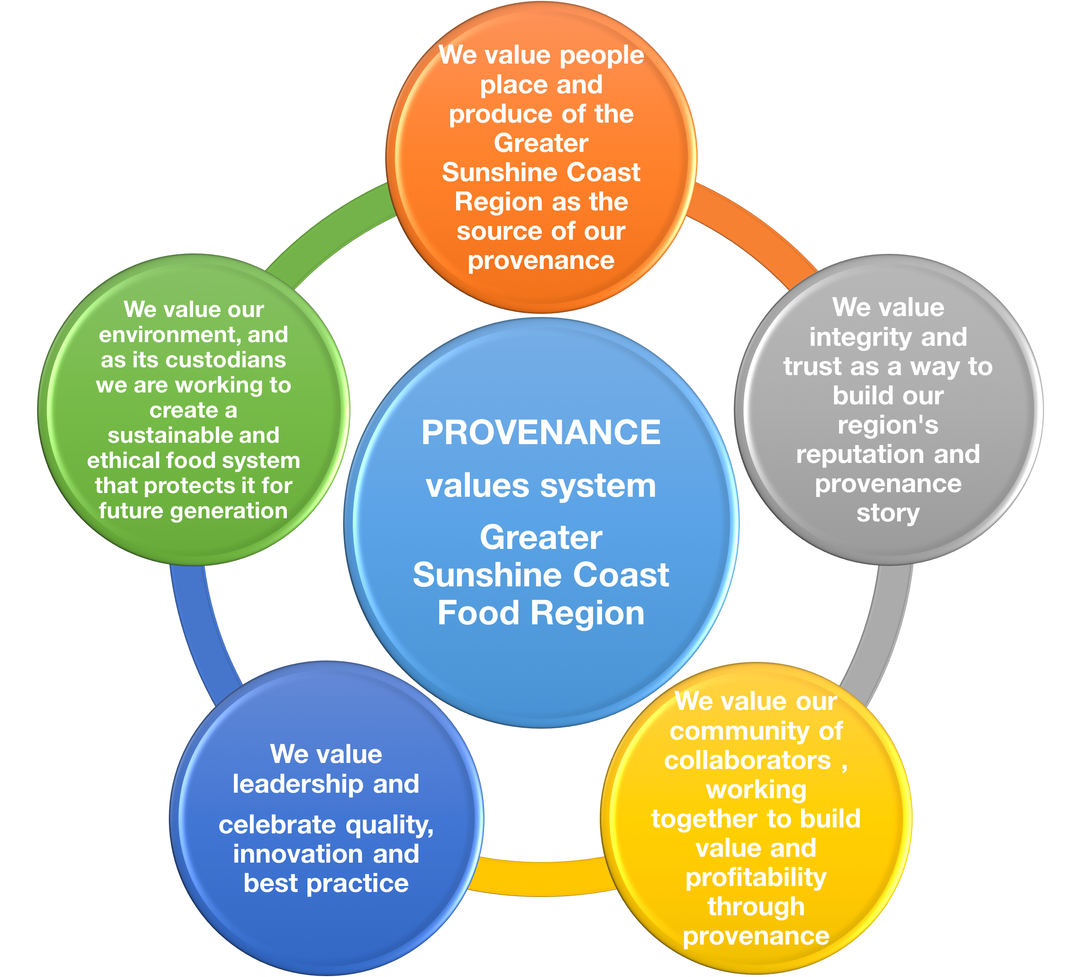
Provenance Values
Five key themes emerged from the discussions with industry, themes included:
Authenticity - We value people place and produce of the Greater Sunshine Coast Region as the source of our provenance
Integrity - We value integrity and trust as a way to build our region's reputation and provenance story
Collaboration - We value our community of collaborators, working together to build value and profitability through provenance
Leadership - We value leadership and celebrate quality, innovation and best practice
Sustainability - We value our environment, and as its custodians we are working to create a sustainable and ethical food system that protects it for future generations

Place (Terroir) | The qualities of the environment, the air, the soil, the climate, topography, the natural state of a place all add qualities and attributes to the produce, product and experience on offer
+ People | The human element, the creativity, culture, the influence people have over the place and produce all influence the product and experience, indeed people create the experience through their influence and interactions and provide content for the regions’ unique story. The character and ambience of a place if reflected by the nature and characteristics of the people. Vibrant and dynamic, cultured and sophisticated or laid back and casual are all human characteristics that we use to personify a place, but in reality it is the people that create the vibe
+ Produce | The ingredients grown, raised or created in a region contribute to the unique combination of local flavours and elements of culinary tourism. The unique combination of flavours and ingredients contributes to the overall story of the destination and the character of the offering
Equals Story | A state, region, product or experience or creates an authentic story by basing it on its unique attributes of People + Place + Produce. The story is more than marketing, it’s part of their identity that resonates with those who tell it and hear it. The story is the foundation of the unique food experience, the story must reflect the elements of People, Place and Produce to be authentic and truly appealing to consumers

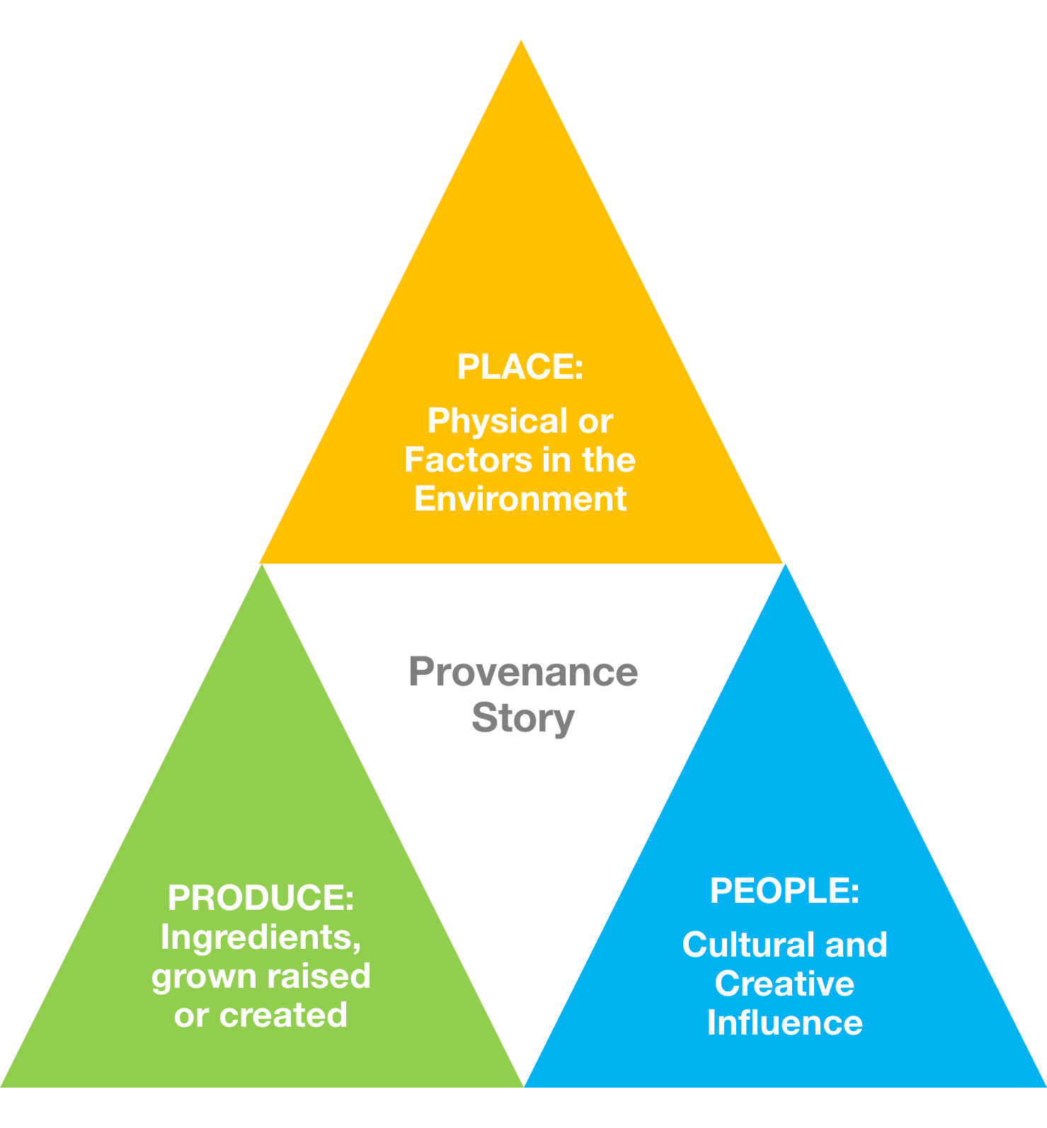
Provenance Story
KTS Story Telling Framework
Element | Concept | Greater Sunshine Coast Narrative
Place (Terroir) | The qualities of the environment, the air, the soil, the climate, topography, the natural state of a place all add qualities and attributes to the produce, product and experience on offer | Clean, lush, warm subtropical environment envelopes the region from the rich red soils of the hinterland and valleys to the pristine coastal waters, the region’s environment provides the perfect conditions for an abundance of fresh seasonal regional produce from the land and sea. The coastal and hinterland environment and climate creates a perfect place to experience the Sunshine Coast’s food culture
+ People | The human element, the creativity, culture, the influence people have over the place and produce all influence the product and experience…. | Creative, cultural and collaborative. Renowned for their casual coastal lifestyle, the people of the Sunshine Coast take their food very seriously. This strong interest in food has its roots deep in a traditional agricultural base, which has innovated from primary production to processing and manufacturing. The food culture has evolved here with strong family traditions being infused with influences from Asia and Europe, creating a diversity of ideas and flavours
+ Produce | The ingredients grown, raised or created in a region contribute to the unique combination of local flavours and elements of culinary tourism. The unique combination of flavours and ingredients contributes to the overall story of the destination and the character of the offering | Big fish and prawns, ginger and pineapples, strawberries and cream (dairy), macadamias and avocados, the Greater Sunshine Coast has both abundance and variety of value added and fresh seasonal regional produce grown, caught, raised and manufactured locally. Vibrant markets and roadside stalls tell the story of seasonality and diversity with bright and bold colours and flavours creating a feast for the senses. Food manufacturers are creative and innovative as they blend the best of the region to create high quality products.
Equals Story | A state, region, product or experience or creates an authentic story by basing it on its unique attributes of People +Place + Produce…. | The Sunshine Coast has a rich, warm, family culture where good food is a local tradition. These traditions have combined with influences from Asia and Europe to create a vibrant and innovative food region. The lush beauty of the environment and natural warmth of the Sunshine Coast is reflected not only in the abundant produce, but the people who create the food and enrich the experience on offer. The Greater Sunshine Coast Food Region is evolving from simple traditions to being an innovative and collaborative food industry. The balance of work, life and environment is a key part of their food story, where food is a labour of love and passion, not just a job. The Greater Sunshine Coast Food Region is best enjoyed in abundance, immersing yourself in the experience.

